**Safeguarding Policy and Safety Awareness at AkiraChix**

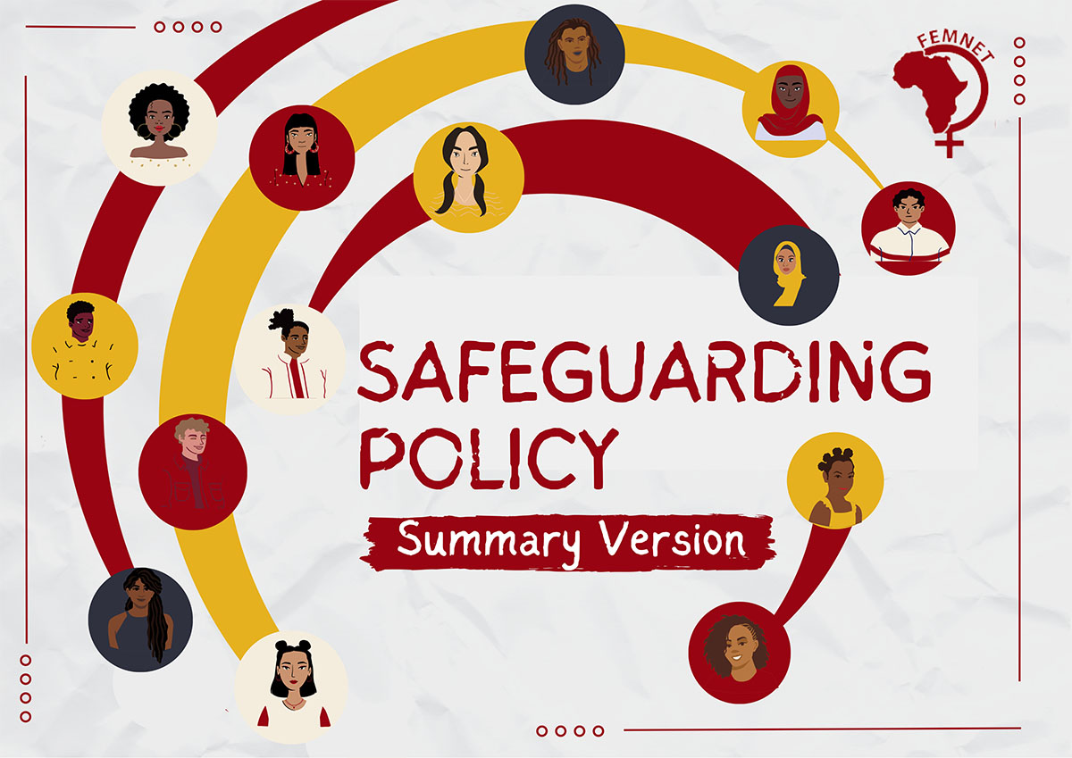

# Introduction

AkiraChix is a place where diversity, differences, and womanhood are celebrated. From 2010 it had a mission to empower, support women, and inspire young girls that anything is possible for a woman. For this reason, the Safeguarding policy was designed to guarantee every AkiraChix member's safety. Also, different trainings are given for this purpose like fire safety awareness training.

# Key points

* Both the policy and the training apply to everyone
* Every member should be responsible and considerate of each other
* There is a safeguarding committee that ensures everything is going according to the signed policy
* For any wrong made by anyone, there should be consequences and punishments so that everyone can learn from them
* There are safeguarding committee rules to abide for submitting complaints

# Conclusion

As AkiraChix members I believe we all take part in ensuring each other safety, so for any discomfort we feel we should advise our safeguarding ambassador for students, and for other staff we should advise the committee and come to common understanding.

For additional information- [AkiraChix Safeguarding Policy](https://drive.google.com/file/d/1ssE_brAd-gcKz7FOyahSAa8mWMkiSKiT/view?ts=67a355b6)